Home Page Correction

- Social media video section add On home page
- Add on WhatsApp button & call button side bar

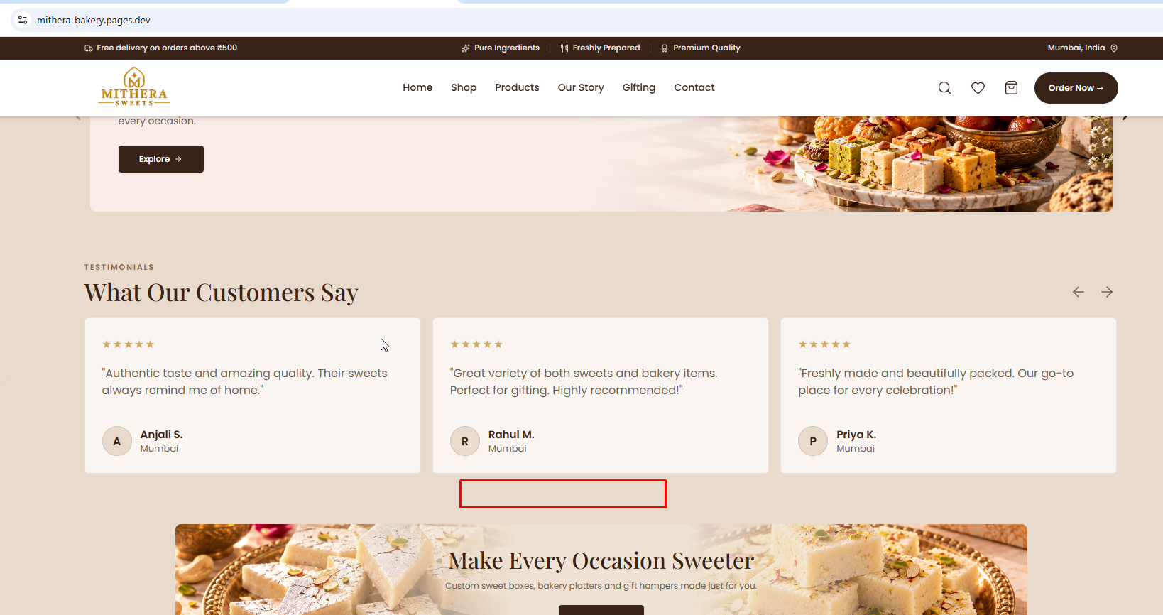

- Add CTA Button for Google Review read karne ke liye.

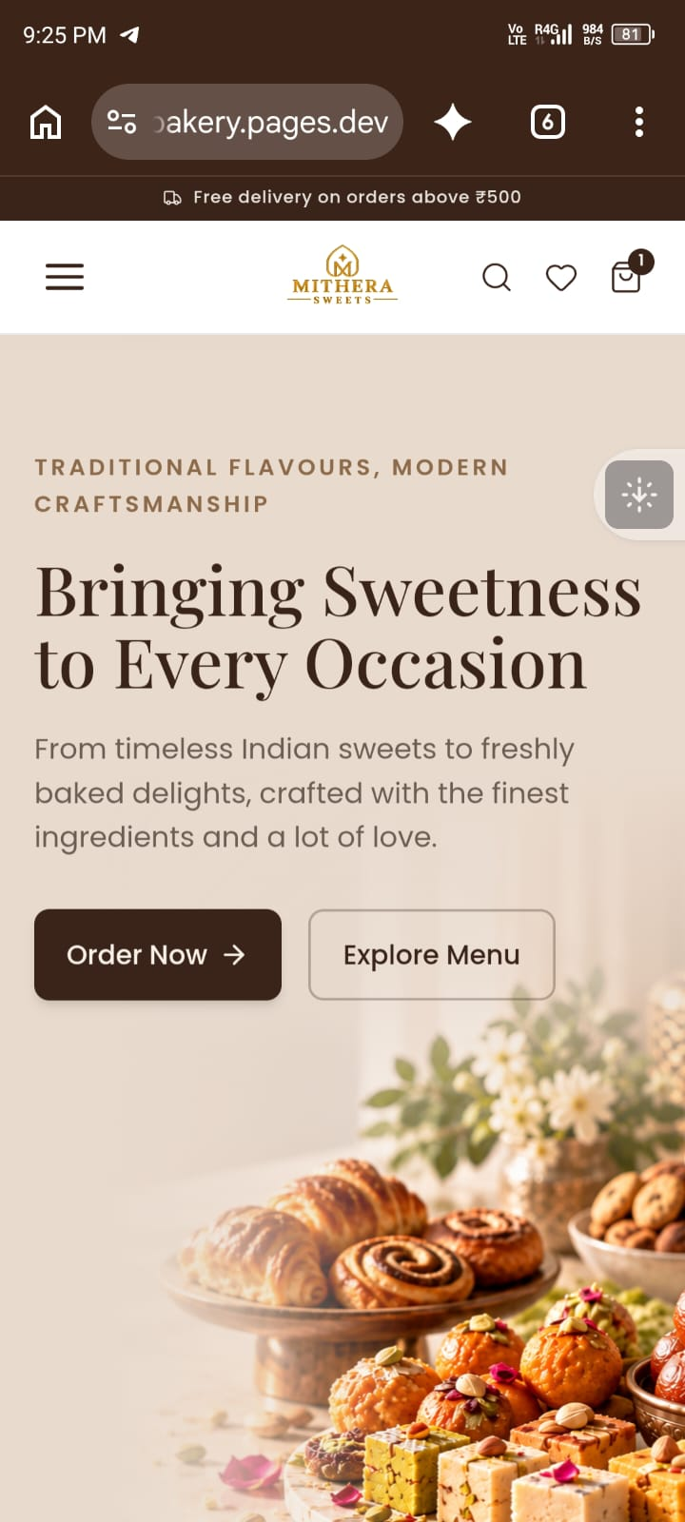

- Phone me image upar rahega aur text bada aur niche rahega.
- Laptop me text aur image ke beech me space kam karo ...

- Particular Product pe review Show karta hai us ko CMS me aysa Setup karo ke jab hum us ko fill kare to frontend me dikhe agar nahi fill karte hai to frontend me nahi dikhna chahiye.
- Laptop me Body centre banner me text ko bada karna hain aur space ko menten karna hain
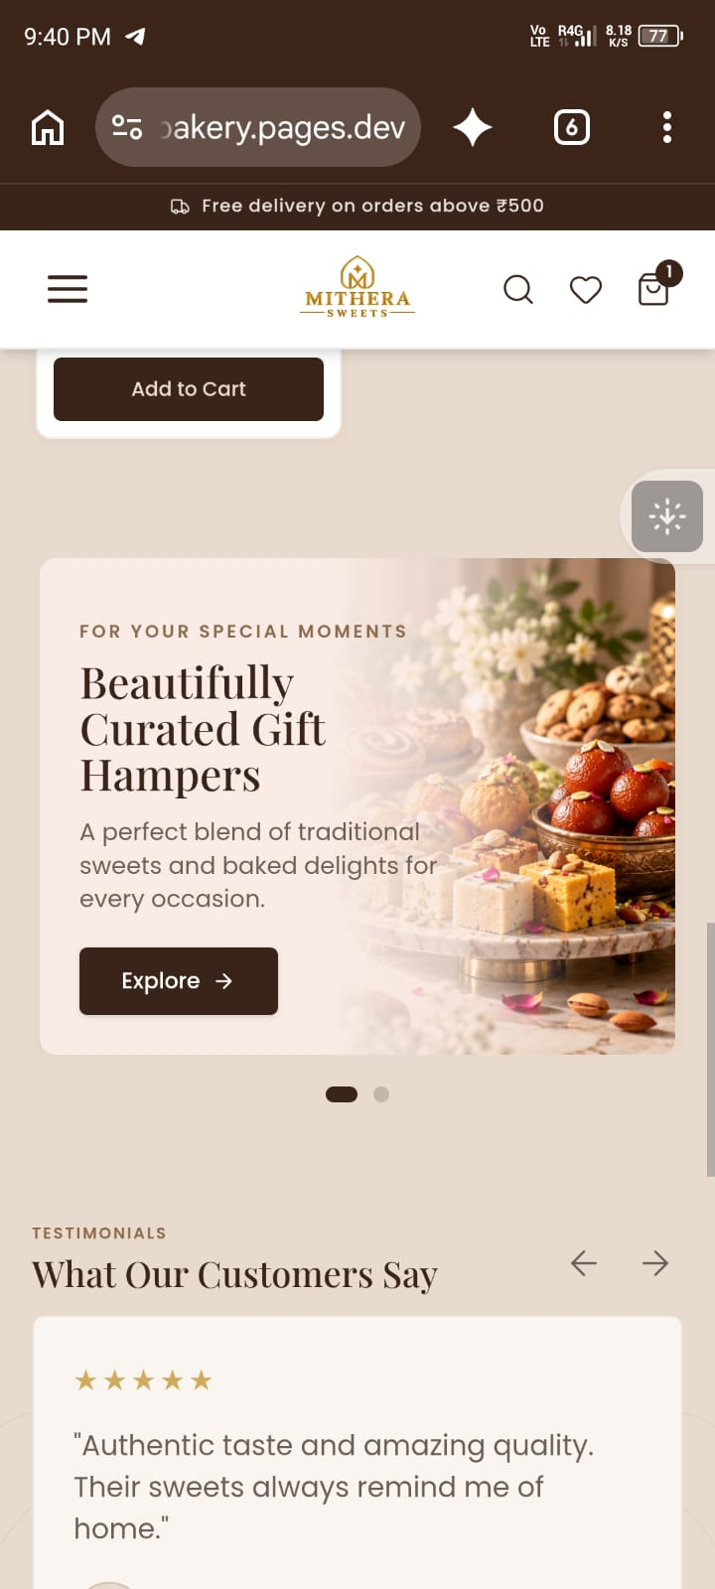
- Explore button pe click karte ho colour brand change hona chahiye …

- FAQs & long content discriptive content section all page me add karna hain, aur us ko CMS se Connect karna hai, aysa setup karna hai ki jab ham CMS me FAQs and Content add karte hai to Frontend me Show hona Chahiye, agar CMS me Nahi add karte hai to Frontend me hide hona chahiye.

Our Story Page

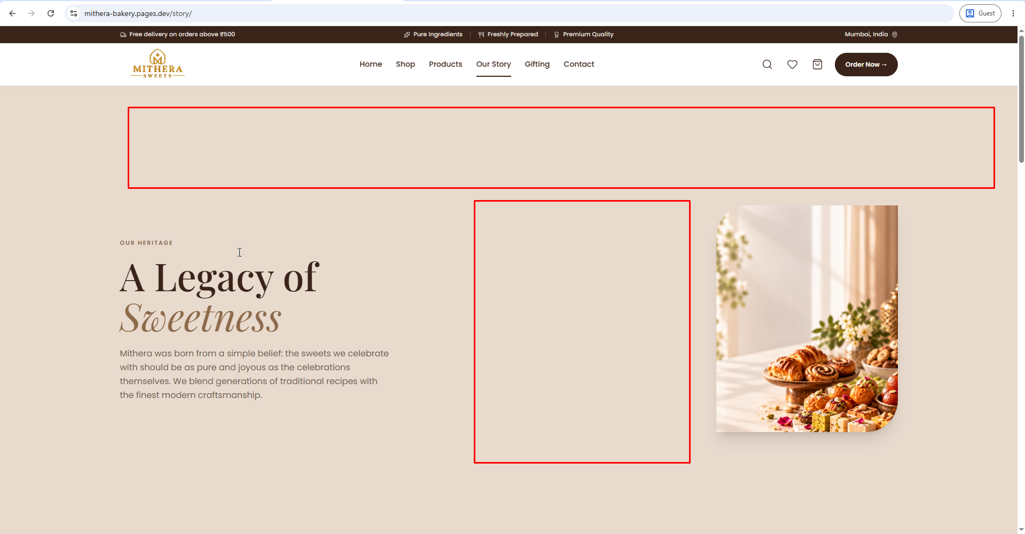

- Hero Baneer me content ke bich me space kam karna hai….

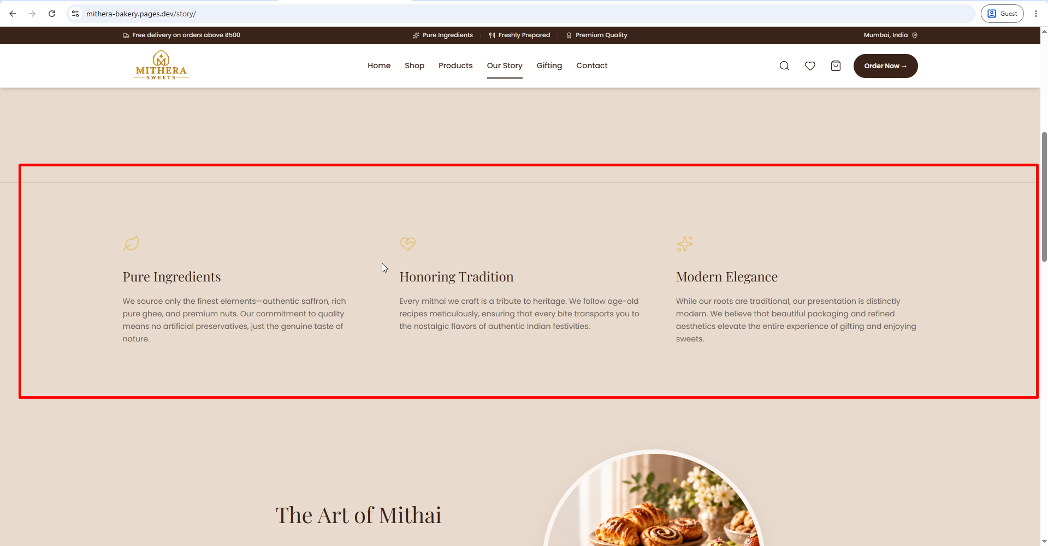

- Is ko attractive card section me dalo

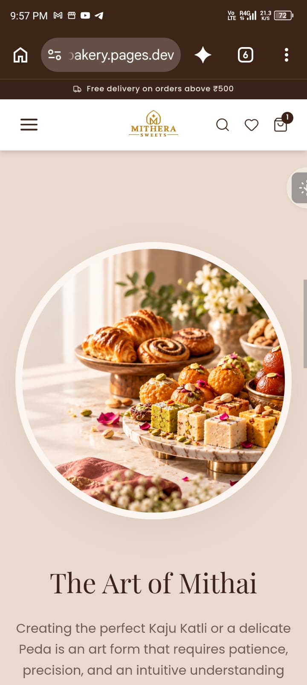

- Is Image ko ya to squre me ya donu ko cercle me kar do …
- Laptop me Spacing tex aur image me Normal karo

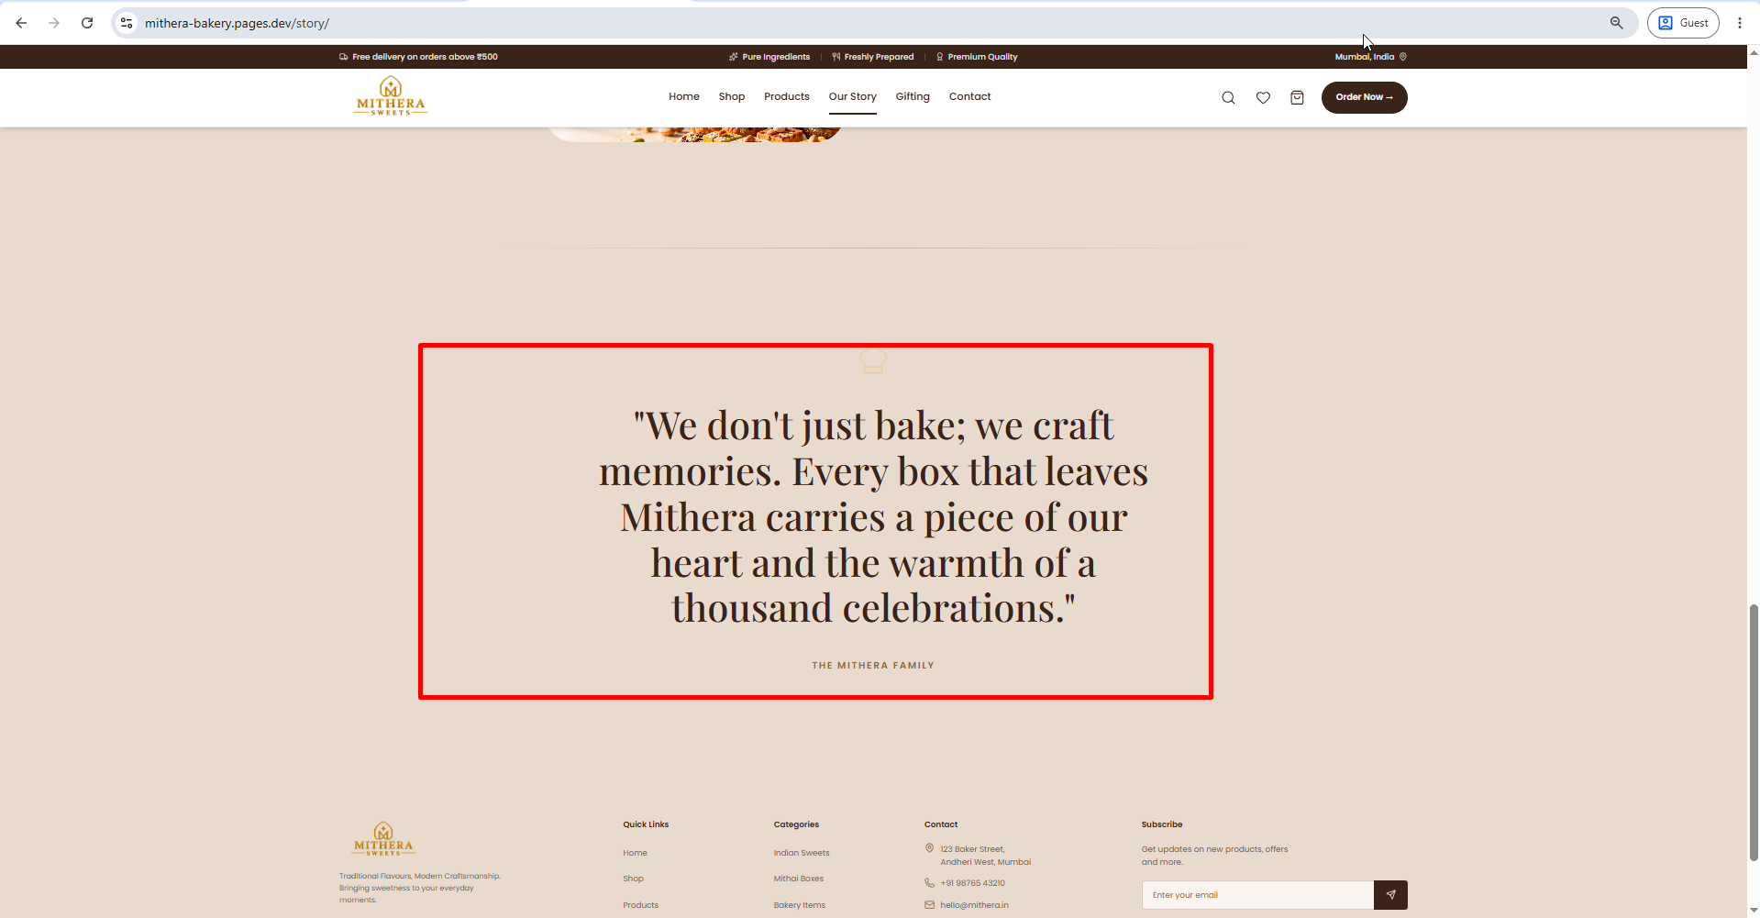

- Ye text upara spacing kam karna hain, Us ko brand background me rakho ..

Gifting Page

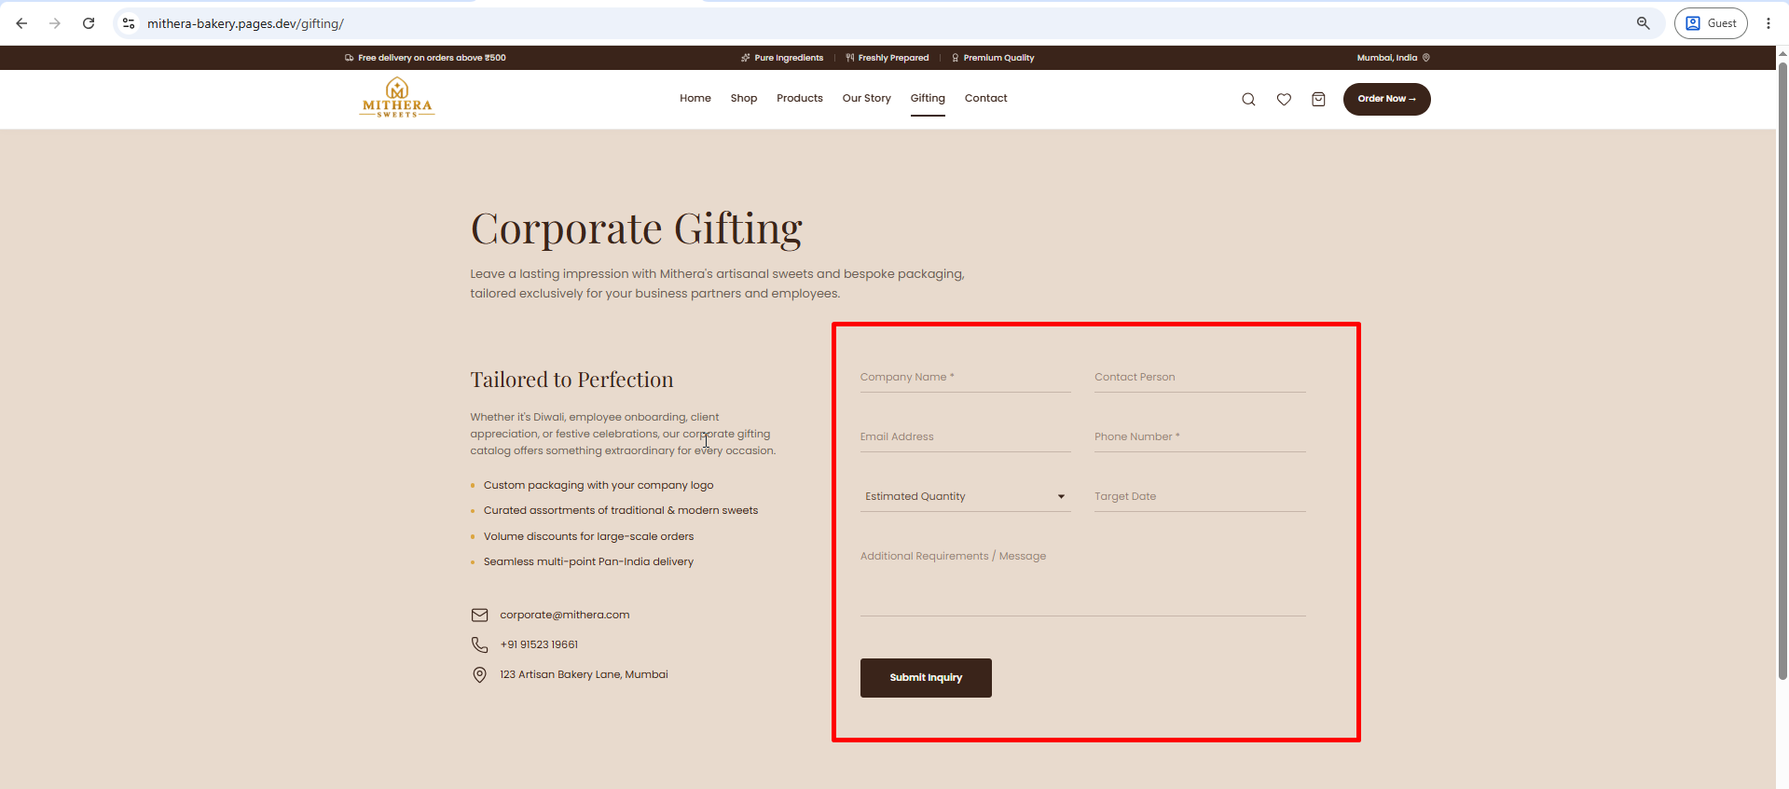

- Inquiry forum ko acche se banavo jo attaract kare

Product Detail Page

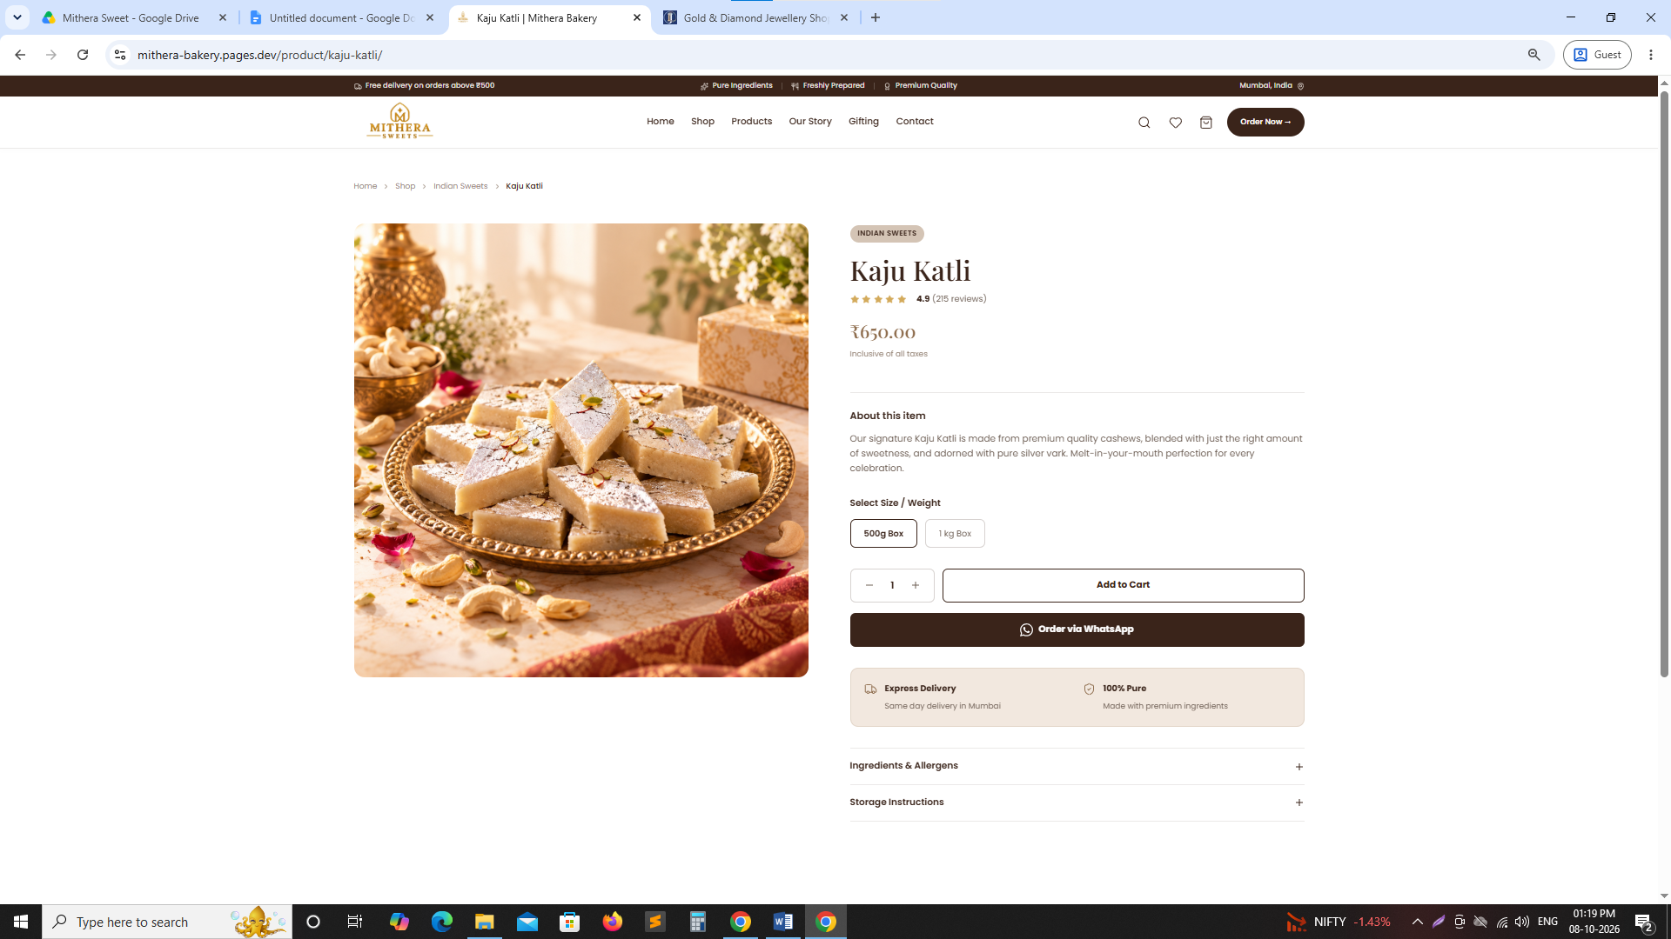

- Only particular Product section hai, us me aur section add karo, jo user ko action lene me help ho.

